2025 New York Jewish Community Recontact Study

uja-federation of new york

Methodology report

Prepared by:
Eran N. Ben-Porath, Ph.D.

Payel Sen, Ph.D.
Emily Jennings

March, 2025

Table of Contents
INTRODUCTION…………………………………………………………………………………………………………………………………………………………..3
SAMPLE AND DATA COLLECTION PROCEDURES………………………………………………………………………………………………………..3
Development of Questionnaire………………………………………………………………………………………………………………………………………………….3
Mailing Procedures…………………………………………………………………………………………………………………………………………………………………….3
Telephone Interviewing……………………………………………………………………………………………………………………………………………………………..4
SMS Reminder……………………………………………………………………………………………………………………………………………………………………………5
Table 1: Contact Schedule by Language………………………………………………………………………………………………………………………………..6
DATA COLLECTION REPORTS 6
Table 2: Number of Interviews by County and Stratum 7
Table 3: Number of Interviews by Mode 7
WEIGHTING 8
Design Weight……………………………………………………………………………………………………………………………………………………………………………8
Recontact Propensity Adjustment………………………………………………………………………………………………………………………………………………8
Non-response Adjustment………………………………………………………………………………………………………………………………………………………...8
Raking………………………………………………………………………………………………………………………………………………………………………………………...9
Table 4. Sample Demographics 9
Effects of Sample Design on Statistical Inference…………………………………………………………………………………………………………………….11
RESPONSE RATES 12
Table 5: Response Rates 12
APPENDIX A: Outreach Materials 13
Letter 1A: Initial Mail Invite 13
APPENDIX B: Questionnaire Screener 17
APPENDIX C: FAQs 18

INTRODUCTION
SSRS conducted the 2025 New York Jewish Community Recontact Study on behalf of UJA-Federation of New York (UJA) between February 5 and March 12, 2025. The study was designed to allow UJA researchers to measure attitudes of the New York Jewish Community in 2025, and track changes compared to the 2023 New York Community Study and the 2024 Antisemitism/Israel Follow-Up Study. For the 2025 New York Jewish Community Recontact Study, SSRS collected data online, by mail and by telephone from 1,348 adults residing in Jewish households in one of the five New York City boroughs, or in Nassau, Suffolk, or Westchester County, NY (“coverage area”). Data collection was completed in three languages (n=1,312 in English, n=34 in Russian, and n=2 in Yiddish). A total of 1,082 respondents completed the 2025 New York Jewish Community Recontact Study online, 79 by outbound CATI, 18 by inbound CATI, and 169 on paper.
This report details the methodological components of the study, including: sample, questionnaire design, programming, field operations, data processing, and weighting.

SAMPLE AND DATA COLLECTION PROCEDURES
The sample included 3,634 respondents who participated in the 2023 NY Jewish Community Survey, screened as a Jewish household, and agreed to participate in future surveys. Although 3,656 respondents had originally agreed to participate in future surveys, 22 respondents opted out of recontact during the 2024 Antisemitism/Israel Follow-Up Study, bringing the total sample for the current study to 3,634.

Development of Questionnaire
The questionnaire design was constructed by UJA, with assistance from SSRS. The questionnaire consisted of up to 50 questions. This includes questions about Jewish identity and practices (e.g. keep Shabbat), experiences as a Jew including antisemitism, attitudes about Israel, and attitudes and practices since October 7, 2023.
SSRS programmed the instrument using Confirmit web/CATI software that integrates data from telephone and web data collection. The survey utilized a responsive design that would alter the layout for mobile devices. Team members reviewed all programs to confirm accuracy of skip patterns and the reasonable flow of the instrument. Testers also scanned the programs with an eye toward respondent usability – to this end, the web survey was tested on a variety of devices and platforms; including smart phones, tablets, and laptop/desktop computers, as well as Chrome, Safari, Firefox, Internet Explorer, and Microsoft Edge.
Once the English version was finalized, the survey was translated by linguists at Cetra Language Solutions. The questionnaire was available in English, Russian, and Yiddish.

Mailing Procedures
A multi-mode, multi-contact strategy was employed to elicit participation. Respondents were contacted in the language in which they completed the 2023 NY Jewish Community Survey. To qualify for the survey, respondents needed to confirm that they were the person who completed 2023 NY Jewish Community Survey. If a name was provided in 2023 NY Jewish Community Survey, respondents were asked to confirm by name. Contacts emphasized the importance of hearing from everyone who participated in our study in 2023. They identified the survey’s sponsor as UJA-Federation of New York and were signed by SSRS president, Melissa Herrmann. The survey was available for completion online, by phone, and through a paper questionnaire.
- Email Invitation:
All respondents who provided an email address as a means of future contact were first contacted by email. Invitations included a passcode-embedded survey link.
- Initial invitation letter:
An initial invitation letter was sent to all respondents who completed the 2023 NY Jewish Community Survey online or by inbound CATI. The letter was sent as first-class mail and included the survey URL and a secure access code unique to the household address. Additionally, a QR code for direct access into the survey via mobile device was included. A toll-free number for those who preferred participating by phone was provided in the invitation.
- Paper Questionnaire
The second mailing included a 4-page paper questionnaire and was sent to all sample who completed the 2023 NY Jewish Community Survey by paper. The mailing also included a stamped business return envelope.
- Reminder Postcard
A final follow-up postcard was sent to all sample who completed the 2023 NY Jewish Community Survey and had not yet completed the current survey. The content of the postcard was similar to the invitation letter, reinforcing the importance of participation in the survey. It included the survey URL and a secure access code unique to the household, as well as a toll-free number and QR code. To boost participation, the reminder postcard mentioned an offer of $10 incentive for those who qualify for and complete the full survey.

Telephone Interviewing
Outbound phone calls were placed to all sample who completed the 2023 NY Jewish Community Survey by outbound CATI in English or Russian. No calls took place from Friday at noon through Saturday. Calls were initiated in the language in which they completed the 2023 NY Jewish Community Survey.
Supervisors and interviewers were briefed by the project team prior to the initial mailing. This briefing covered the study objectives, screening process, as well as reviewed individual questions and pronunciations as needed. Supervisors and interviewers were provided with examples of the mailing materials provided to respondents. A FAQ document was also provided for interviewers to refer to if needed (see Appendix C).
A toll-free number was supplied to respondents in the event they wanted to call in to ask questions about the web survey or to complete the survey over the phone with a trained interviewer. When respondents called the toll-free number, they reached an answering message directing them to dial a number for each available language (English, Russian, Yiddish). If a respondent called during call center business hours and selected English, they were connected with a live SSRS telephone interviewer in that language to complete the survey or answer any questions about the survey. If a respondent called outside of call center business hours or selected another language, they were directed to leave a voicemail, and a telephone interviewer returned their call in the selected language in the next business day.

SMS Reminder
SMS (text messaging) outreach was implemented in collaboration with Survey160, a company specializing in text-messaging for research, to increase completion rates among respondents. Respondents who previously participated in English, using a cell phone, and who were under age 35, were contacted twice by text message. Respondents who previously participated in English, using a cell phone, and who are over age 35, received one contact by text message.
Survey160 interviewers sent a short introduction through text message, “Hi,I am (interviewer name) with SSRS. Can you answer some follow-up questions for the New York Community Study?” along with answer options. Respondents who texted back, “Yes”, or “1” were sent one follow-up message including a passcode-embedded link to the online survey. Interviewers were additionally trained to answer FAQ’s, such as who is conducting this study and why we are contacting them.
65 respondents accessed the survey through the SMS link and completed the survey.

Table 1: Contact Schedule by Language
 | English | Russian | Yiddish
Mailing #1: Initial Invitation Letter | February 5, 2025 | February 5, 2025 | February 5, 2025
Email #1 | February 7, 2025 | February 10, 2025 | February 10, 2025
Outbound Phone Call Start Date | February 10, 2025 | February 20, 2025 | N/A
Mailing #2: Invitation with Paper Questionnaire | February 10, 2025 | February 10, 2025 | February 10, 2025
Email #2 | February 13, 2025 | February 13, 2025 | February 13, 2025
Email #3 | February 16, 2025 | February 16, 2025 | February 16, 2025
Email #4 | February 20, 2025 | February 20, 2025 | February 20, 2025
SMS Reminder 1 to Under 35 | February 20, 2025 | N/A | N/A
Email #5 | February 24, 2025 | February 24, 2025 | February 24, 2025
Mailing #3: Reminder Postcard | February 25, 2025 | February 25, 2025 | February 25, 2025
Email #6 | February 27, 2025 | February 27, 2025 | February 27, 2025
Email #7 | March 4, 2025 | March 4, 2025 | March 4, 2025
SMS Reminder 2 to Under 35 | March 7, 2025 | N/A | N/A
Email #7 | March 9, 2025 | March 9, 2025 | March 9, 2025
Email #8 | March 11, 2025 | March 11, 2025 | March 11, 2025
SMS Reminder to Above 35 | March 12, 2025 | N/A | N/A
Close of Field | March 12, 2025

DATA COLLECTION REPORTS
A total of 1,348 respondents completed the questionnaire. Table 2 below details the number of completes from each of the eight counties by sampling stratum. Questionnaires completed through the section on attitudes and practices since October 7 were considered complete.

Table 2: Number of Interviews by County and Stratum
 | Total Completed | Federation List | Jewish Model | Drop  Units | High Residual | Low  Residual | Non-Federation Community List
Bronx | 64 | 26 | 14 | 0 | 1 | 0 | 23
Brooklyn  (Kings County) | 403 | 86 | 133 | 22 | 15 | 21 | 126
Nassau County | 201 | 92 | 27 | 0 | 18 | 3 | 61
Manhattan  (New York County) | 298 | 127 | 80 | 8 | 18 | 22 | 43
Queens | 162 | 51 | 20 | 6 | 7 | 14 | 64
Staten Island  (Richmond County) | 20 | 5 | 2 | 4 | 0 | 1 | 8
Suffolk County | 53 | 23 | 6 | 0 | 2 | 14 | 8
Westchester County | 147 | 76 | 25 | 0 | 4 | 3 | 39
TOTAL INTERVIEWS | 1,348 | 486 | 307 | 40 | 65 | 78 | 372

The majority of interviews (80%) were completed online, 13% completed by paper, and 7% completed by telephone. Table 3 details the number of completed questionnaires by mode of data collection, and language.

Table 3: Number of Interviews by Mode
Main | Laptop/Desktop | Mobile Device | Total Online | Telephone | Paper | TOTAL
English | 754 | 314 | 1,068 | 90 | 154 | 1,312
Russian | 9 | 5 | 14 | 7 | 13 | 34
Yiddish | 0 | 0 | 0 | 0 | 2 | 2
Total | 763 | 319 | 1,082 | 97 | 169 | 1,348

WEIGHTING
Data were weighted to represent adults in New York (NY) Jewish households. The data were weighted by applying a base weight and balancing the demographic profile of the sample to target population parameters.

Design Weight
This survey contains recontacted adults in NY Jewish households from the initial study who agreed to be contacted for follow up studies. The initial design weight is the final trimmed respondent weight from the original study, trimmed again to 5% on the sample of consenters. This weight is then adjusted for bias stemming from differences between willing to be recontacted and non-response.

Recontact Propensity Adjustment
A propensity adjustment is used to correct for bias stemming from differences between respondents willing to be recontacted for a second interview, and those who are not.
Characteristics of the respondents as measured in the initial survey were used to model their probability of consenting to be recontacted for the second survey. Propensity is modeled through logistic regression in which the dependent variable is whether a respondent agreed to be recontacted. The predictive values are calculated as the probability of a person agreeing to be recontacted.
The recontact propensity adjusted base weight (RP_BW) is calculated as product of the design weight and the inverse of the predicted probability of consent to be recontacted calculated by the logistic regression model. Variables used in this model include interview mode, sample strata, Jewish denomination, part of Jewish community, Jewish prayer service attendance, Synagogue membership, visit Israel frequency, emotional attachment to Israel, Jewish parents, county, and household language.

Non-response Adjustment
The design weights are then adjusted for nonresponse on the sample of people who agreed to be recontacted. A conditional inference tree is run to determine nonresponse adjustment cells. The nonresponse adjustment is typically done independently within classes of cases. In the inference tree model, the dependent variable is whether a person completed the recontact survey. Variables used in this model include interview mode, sample strata, gender, age, education, race/ethnicity, number of adults in household capped at 3, presence of children in household, Jewish denomination, Jewish parents, county, and household language.
The adjustment factor is calculated as:
$$NR_ADJ= \frac{\sum_{sample of recontacts}{RP_BW}}{\sum_{complete}{RP_BW}}$$
That is, the sum of the recontact propensity adjusted base weights among all people who agreed to be recontacted, divided by the sum of the recontact propensity adjusted base weights among all cases with a completed recontact survey.
The nonresponse-adjusted base weight (NR_BW) is defined for completes only and incorporates the nonresponse adjustment factor.
$$NR_BW= \left\{\begin{aligned}RP_BW×NR_ADJ, if complete \\ 0, otherwise\end{aligned}\right\}$$
The final base weight is the non-response adjusted base weight, trimmed to 5%.

Raking
With the base weight applied, the data were weighted to balance the demographic profile of the sample to the target population parameters.
Missing data in the raking variables were imputed using hot decking. Hot deck imputation replaces the missing values of a respondent randomly with another similar respondent without missing data. Hot decking was done using the hotdeck function from the R package VIM.
Weighting was accomplished the R package ANESRAKE.
Data were weighted to the distributions of: gender, age, education, presence of children in household, poverty, part of Jewish community, Jewish prayer service attendance, Synagogue membership, visit Israel frequency, emotional attachment to Israel, county, and household language. Benchmarks were calibrated using the respondent weight in the initial survey.
Weights were trimmed at the 5th and 95th percentiles to prevent individual interviews from having too much influence on survey-derived estimates. The table below compares unweighted and weighted sample distributions to target population benchmarks.

Table 4. Sample Demographics
Category | Values | Parameter | Unweighted | Weighted
Gender | Male | 49.6% | 48.5% | 50.6%
Gender | Female | 50.4% | 51.5% | 49.4%
Age | 18-29 | 22.3% | 6.8% | 19.2%
Age | 30-49 | 29.9% | 21.5% | 30.6%
Age | 50-64 | 22.0% | 22.9% | 23.2%
Age | 65+ | 25.8% | 48.8% | 27.0%
Education | Some coll or less | 37.7% | 14.9% | 34.6%
Education | College grad + | 62.2% | 85.1% | 65.4%

Presence of children in HH | No | 69.7% | 78.9% | 69.3%
 | Yes | 30.3% | 21.1% | 30.7%
Poverty | Under 100% FPL | 6.7% | 6.4% | 6.4%
Poverty | 100%-150% | 5.1% | 3.0% | 5.1%
Poverty | 150%-250% | 6.8% | 8.9% | 7.1%
Poverty | 250+ | 81.3% | 81.7% | 81.4%
County | Bronx | 2.8% | 4.7% | 3.0%
County | Kings | 26.6% | 29.9% | 27.2%
County | Nassau | 15.4% | 14.9% | 15.7%
County | Manhattan | 21.9% | 22.1% | 21.8%
County | Queens | 13.2% | 12.0% | 13.1%
County | Richmond | 3.8% | 1.5% | 3.3%
County | Suffolk | 8.2% | 3.9% | 7.6%
County | Westchester | 8.0% | 10.9% | 8.4%
Feeling part of Jewish community | Not at all | 22.3% | 8.8% | 19.4%
Feeling part of Jewish community | Only a little/Some | 47.8% | 48.3% | 48.6%
Feeling part of Jewish community | A lot | 29.9% | 43.0% | 32.0%
Jewish prayer service | Never | 45.0% | 30.4% | 43.0%
Jewish prayer service | Few times a year/Every few months | 31.3% | 36.1% | 31.6%
Jewish prayer service | Once or twice a week | 4.4% | 7.2% | 4.8%
Jewish prayer service | At least once a week | 10.5% | 18.1% | 11.3%
Jewish prayer service | Valid Missing | 8.8% | 8.2% | 9.2%
Synagogue membership | Yes | 27.1% | 41.8% | 28.6%
Synagogue membership | No | 64.1% | 49.9% | 62.1%
Synagogue membership | Valid Missing | 8.8% | 8.2% | 9.2%

Visit Israel | Never | 44.3% | 30.4% | 42.4%
Visit Israel | Once | 18.2% | 22.6% | 19.1%
Visit Israel | Twice or more | 27.0% | 37.6% | 28.6%
Visit Israel | Lived in Israel | 4.8% | 7.6% | 5.1%
Visit Israel | Don’t know/Refused | 5.7% | 1.7% | 4.7%
Emotionally attached to Israel | Not at all attached | 23.7% | 10.7% | 22.2%
Emotionally attached to Israel | Not very attached | 17.7% | 17.4% | 18.1%
Emotionally attached to Israel | Somewhat attached | 28.1% | 31.6% | 28.7%
Emotionally attached to Israel | Very attached | 24.0% | 38.1% | 25.7%
Emotionally attached to Israel | Don’t know/Refused | 6.4% | 2.2% | 5.3%
Household language | English | 67.1% | 72.3% | 67.4%
Household language | Russian/Hebrew/Yiddish | 21.2% | 20.4% | 21.4%
Household language | Other | 11.7% | 7.3% | 11.1%

Effects of Sample Design on Statistical Inference
Post-data collection statistical adjustments require analysis procedures that reflect departures from simple random sampling. SSRS calculates the effects of these design features so that an appropriate adjustment can be incorporated into tests of statistical significance when using these data. The so-called "design effect" or deff represents the loss in statistical efficiency that results from a disproportionate sample design and systematic non-response. The total sample design effect for this survey is 3.44.
SSRS calculates the composite design effect for a sample of size n, with each case having a weight, w, as:
$$deff=\frac{n\sum{w^{2}}}{{\left(\sum{w}\right)}^{2}}$$

The survey’s margin of error is the largest 95% confidence interval for any estimated proportion based on the total sample — the one around 50%. For example, the margin of error for the entire sample is ± 4.9 percentage points. This means that in 95 out of every 100 samples drawn using the same methodology, estimated proportions based on the entire sample will be no more than 4.9 percentage points away from their true values in the population. Margins of error for subgroups will be larger. It is important to remember that sampling fluctuations are only one possible source of error in a survey estimate. Other sources, such as respondent selection bias, questionnaire wording, and reporting inaccuracy, may contribute additional error of greater or lesser magnitude.

RESPONSE RATES
All sample included in the 2025 New York Jewish Community Recontact Study was considered eligible. The overall response rate for the 2025 New York Jewish Community Recontact Study was calculated to be 37%. Below are dispositions and response rate for each sampling stratum.

Table 5: Response Rates
Disposition | CLS | Jewish Model | Drop  Unit | High Jewish | Low  Jewish | Total
C (Complete) | 858 | 307 | 40 | 65 | 78 | 1,348
TOTAL | 2,115 | 952 | 109 | 194 | 264 | 3,634
RR | 40.6% | 32.2% | 36.7% | 33.5% | 29.5% | 37%

APPENDIX A: Outreach Materials

Letter 1: Initial Mail Invite
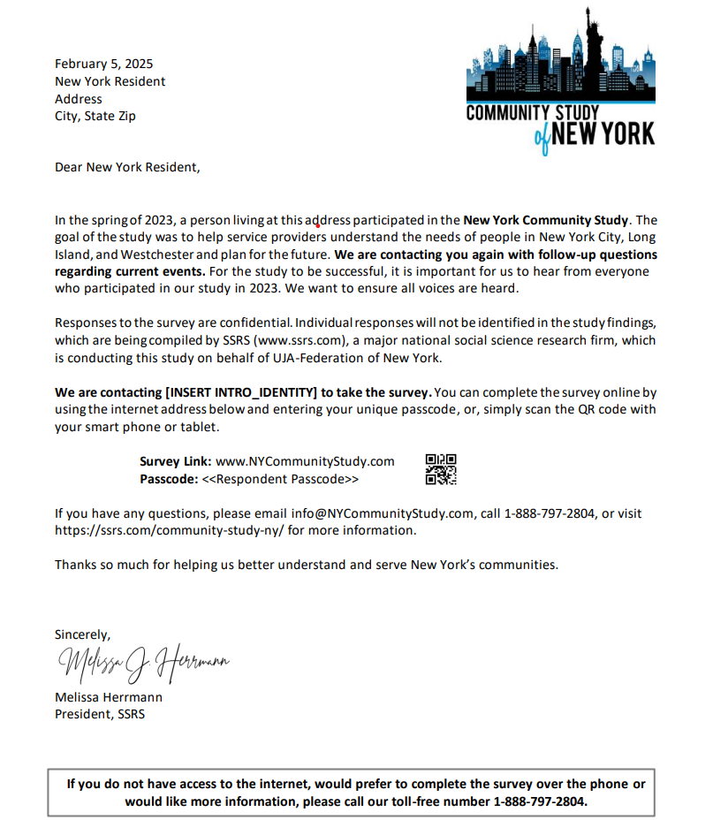

Letter 2: Mail Reminder 1 with paper questionnaire
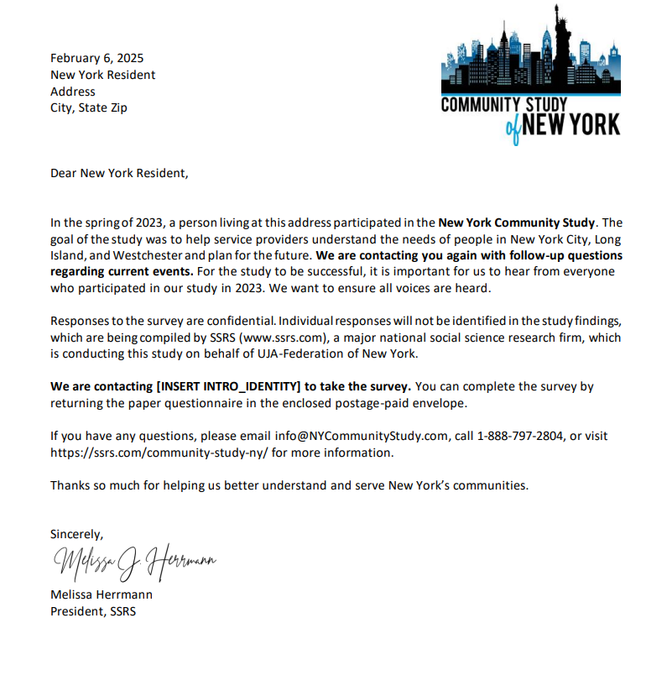

Letter 3: Apology mail
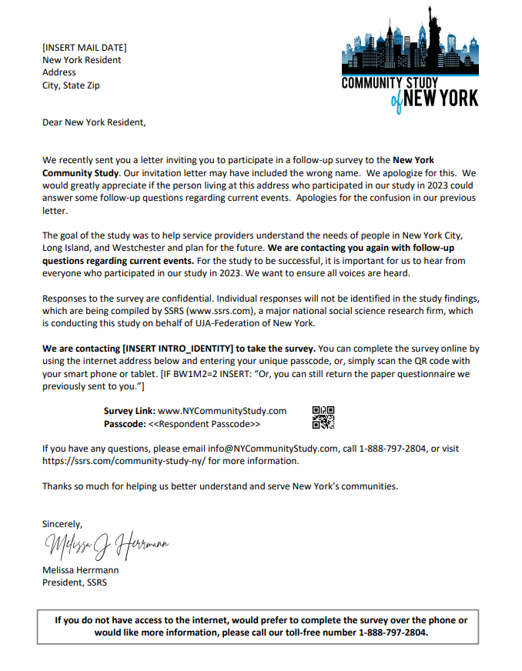

Letter 4: Reminder Postcard
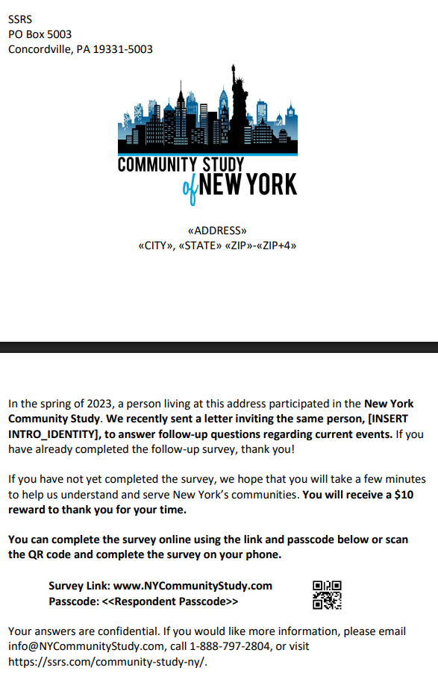

APPENDIX B: Questionnaire Screener
(ASK IF WEB INTERVIEW)
YSC6. To confirm, are you the person who participated in our survey in the spring of 2023?

001 Yes
002 No
999 BLANK

(ASK if YSC6=002,999 , respondent not 18 or older/blank)
YS2A1 [UNDER18]. Thank you for your time. As mentioned in the invitation letter, we’d like to hear again from the person who participated in our survey in the spring of 2023. Can this person participate?

1 Yes
2 No -- PROGRAMMER NOTE: Terminate interview. Code the termination in a way that does not block another household member from completing the survey.

(ASK IF YS2A1=1 and WEB MODE)
YS2A2. Please ask them to take this survey at their convenience. Thank you.

YS1. What county do you live in most of the time?

IF CATI: (READ LIST)

001 Bronx
002 Brooklyn
003 Manhattan
004 Queens
005 Staten Island
006 Westchester
007 Suffolk
008 Nassau
009 Other
998 CATI SHOW (DO NOT READ)/WEB HIDE: Don’t know
999 CATI SHOW (DO NOT READ)/WEB HIDE: Refused
999 (WEB) Blank

IF YS1=009, 998, 999; TERMINATE INTERVIEW “Thank you for participating. We are interviewing residents who live in specific New York counties.”

APPENDIX C: FAQs
The Community Study of New York
(INSERT LOGO)
FREQUENTLY ASKED QUESTIONS

Why was I contacted for this study?
You were contacted because in the spring of 2023 you, or a person living at your address, participated in a survey of adults in the New York area who are Jewish or live with someone who is Jewish. We are contacting you again in view of current events. We are interested in your opinions and experiences over the past few weeks.

What kind of information does this study collect?
This study collects information about your opinions about current events and how they affect you and your household. We will also ask a few questions about you, such as your age or education.

Your answers are completely confidential and individual contact information (name, address, phone number, or email address) will NOT be shared by the survey company with the survey sponsor or any other organizations. All your answers will be combined anonymously with the answers of other New Yorkers who participate.

What is the purpose of this study?
The study will allow UJA-Federation and other organizations in the New York area understand how recent events affected, if at all, the Jewish population in the New York area. The findings will be used by local nonprofit organizations in New York City, Long Island, and Westchester to address the needs of New Yorkers.

We are not asking for money or selling anything. This survey is for research purposes only.

Why is my participation so important?
Your household was part of the New York Community Study that took place in the spring of 2023. This was a survey of randomly selected households in the New York area that are broadly representative of people in Jewish households. We need everyone who participated in this study to respond to the current survey to ensure the sample remains representative. We cannot achieve our goals without your help.

Who is conducting this study?
This study is funded by UJA-Federation of New York (www.ujafedny.org), which supports hundreds of nonprofit organizations serving the New York population. As the world’s largest local philanthropy, UJA can quickly mobilize its local and global network in times of crisis. It helps meet ongoing and emerging needs of New Yorkers of all backgrounds and strengthens Jewish communities in New York and around the world.

The study is being conducted by SSRS (www.ssrs.com), a major national social science research firm. This team was assembled to make certain that the information collected meets the highest standards and provides the data needed for effective community planning.
Will the results be available?
Yes. The data will be made publicly accessible and survey results will be published in the spring of 2025 on UJA’s website and through an interactive web tool. As a reminder, no results will be published in which individuals can be identified.

Who is participating in this study?
This study is collecting information from the thousands of households in New York City, Long Island, and Westchester that participated in the New York Community Study in 2023. Adults of all backgrounds participated in this study. We hope to reach different segments of the community to get an accurate picture of the population.

How did you get my address?
Your address was originally randomly selected from all residential addresses in New York City, Long Island, and Westchester. All addresses had a chance of being selected to ensure the survey represents all New Yorkers. Addresses were available through publicly accessible data. We are currently contacting you based on information provided to us in our earlier survey.

What if I do not want to answer a particular question?
Then it is fine to simply leave it blank. Please be assured your answers will be kept confidential. Individual contact information (name, address, phone number, or email address) will NOT be associated with your answers.

How long will it take? Can I start the survey now and finish another time?
On average, the survey takes less than 15 minutes. You may start the survey and finish it another time; the program will automatically save your work. When you sign back on, you will need the code from the letter that invited you to participate. You will be taken right to the point where you left off.

More Information
If you have any additional questions about this study, please contact the project team at SSRS by emailing info@NYCommunityStudy.com.

In the initial and second mailing invitations, 697 respondents received invitations addressed to incorrect names. To rectify the issue, a follow-up letter and email was sent to these cases including the correct name of each respondent and an apology for the mistake.
Kowarik A, Templ M (2016). “Imputation with the R Package VIM.” Journal of Statistical Software, 74(7), 1–16. doi:10.18637/jss.v074.i07.
https://cran.r-project.org/web/packages/anesrake/anesrake.pdf
Kish, L. (1992). Weighting for Unequal Pi. Journal of Official Statistics, Vol. 8, No.2, 1992, pp. 183-200.

